S. No. | Experiment Detail
1 | Write HTML Code to display the following output and also display the title using heading tag.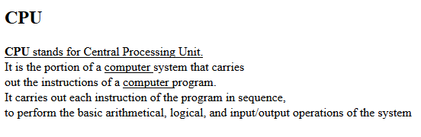
2 | Write HTML code for below diagram by using horizontal line, heading tag, colors to suitably distinguish headings, font styling like italics and underline.  
3 | Demonstrate the usage of formatting, marquee and blink tag to print below output.  Various formulas (Marquee)  H₂O  H₂SO₄  Text  _{X}²  X² + Y²=Z  Y = mx + c
4 | Write HTML code to display following List  - Linux  - Unix  - HTML  - DHTML  - JavaScript  - Perl  - PHP  - SQL  - Oracle  - CCNA
5 | Write HTML code to display following List  Bachelor of Engineering  - CSE  - Software Engineering  - Data Structures  - Theory of Computation  - ME  - Strength of Material  - Mobility  - ECE  - VLSI design  - Wireless communication
6 | Write the HTML code to add a link on the text “Click here” and image of “Chitkara university logo”, when you click on these link then open www.chitkara.edu.in.
7 | Create a document with two links to an external document. The first link should lead to the beginning of the external document. The second link should lead to a particular section in the external document.
8 | Create an image-map, with clickable regions. Use image of India and create link for any 5 states.
9 | Write HTML code for the following table :
  S.No. | Particulars | No. of Items | Price
  1. | Hard Disks | 2 | 4000.00
  2. | Monitors | 3 | 15000.00
  3. | CD ROM | 2 | 1000.00
  4. | DVD Writer | 4 | 6000.00
10 | Create a table to show your class time-table.
11 | Write HTML code the following form:  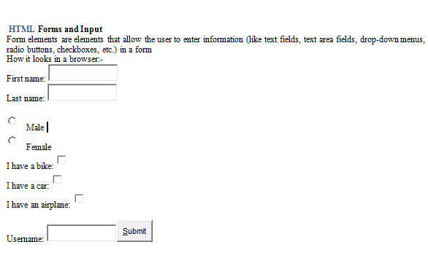
12 | Write HTML code for the following frames:  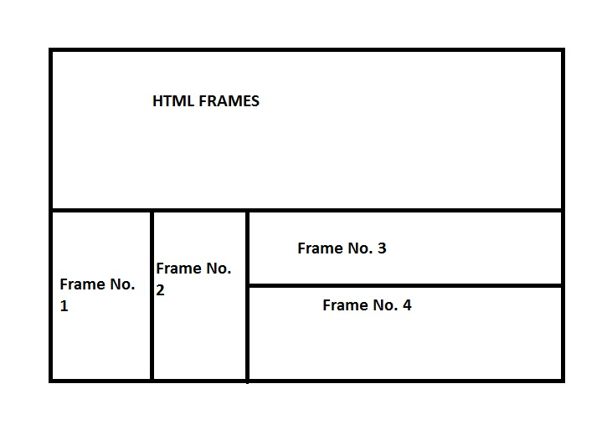
13 | Write HTML code to display frame  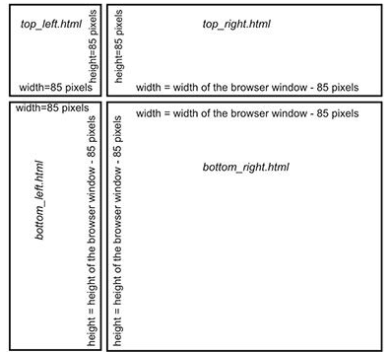  In top-left corner insert an image. In top_right give a good caption to your page. In bottom_left provide various hyperlinks which should open in Bottom_right frame.
14 | Write a HTML code to create iframe. (Display a web page within a web page).
15 | Change the text color, background color and text size of paragraph and list using internal Style sheet and External Style sheet.
16 | Write a code to display a message after some delay specified by user using JavaScript.
17 | i) WAP to print series from 10 to 1 using JavaScript.  ii) Write a program to demonstrate the working of alert box, confirm box and prompt box.
18 | i) WAP to input five elements in and array and print using JavaScript  ii) Write a JavaScript program to change background color after 5 seconds of page load.
19 | i)WAP to find factorial of a number using JavaScript  ii) WAP to display all the prime numbers between 1 to 100.
20 | WAP to implement Java Script – event handling like onblur, onchange, ondbclick, onclick, onfocus, onkeydown, onkeyup, onkeypress, onload, onunload, onmouseover, onmouseout, onmousedown, onmouseup, onmousemove, onreset, onselect, onsubmit.
21 | Implement Javascript Objects: Maths, String ,Date, Array.
22 | Use getElementsByTagName, getElementsById, getElementsByClassName method to find the <p> element, and change its text to "Hello World!". Also change the value of HTML element.
23 | Implement DOM Node properties: childnodes, firstnode, lastnode, nodename, nodetype, nodevalue, parent node.
24 | Implement DOM Node methods by making a list of grocery items purchased from super market using appendchild() and remove child(), createnode() and text type Node creation, node removal, Traversing a Document's Nodes
25 | Implement DOM Objects: Window, History object with their method and properties
26 | Implement DOM Objects: Location, Document, Form object with their method and properties
27 | WAP to implement validation on form in Javascript.
28 | Use the on() method to attach a click event handler to all <p> elements. Similarly, implement jQuery event elements and methods for the same.
29 | Using jQuery animate () method create custom animations. Also implement chaining effect by writing a paragraph and insert a button, on clicking button chaining effect of paragraph and button occurs
30 | Insert three paragraphs and using the children() method add a red color to the first child element of <div>.
31 | Use a jQuery method to slide down the <div> element. The duration of the effect should be 5000 milliseconds.
32 | Implement all jQuery Selectors
33 | WAP for a basic Bootstrap page with a responsive full width container and a grid shown below. (Style it with different colors).  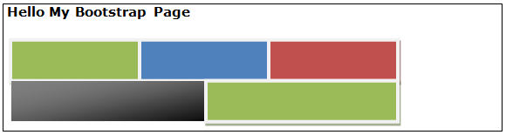
34 | WAP to implement the looks of a Profile page given below.  - Place the heading in a big box  - Place your circled image on the left grid.  - Place a responsive, striped table on the right side of the grid.  - Use grid and full width container.  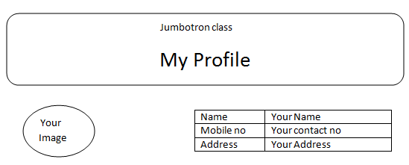
35 | WAP to Implement Inverted Navbar and collapsible List group i.e. on clicking list group it should be collapsible.  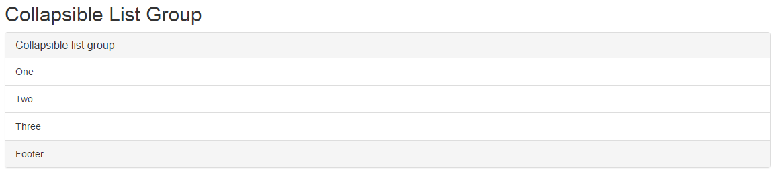
36 | WAP to implement bootstrap carousel. The Carousel plugin is a component for cycling through elements, like slideshow.  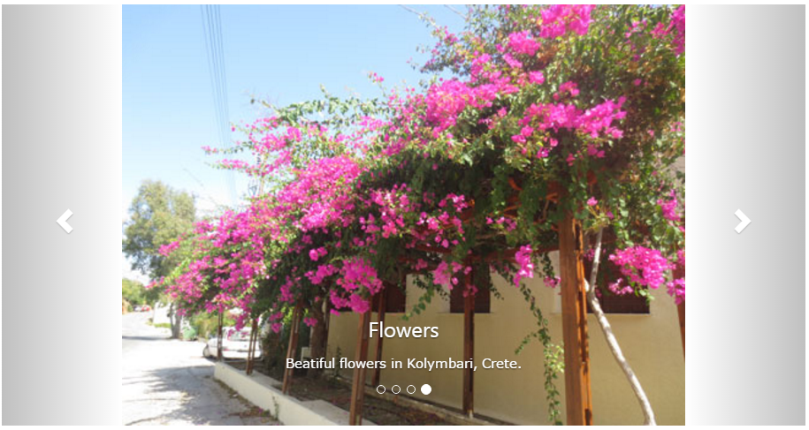

6. Evaluation Scheme:
Lab Component 1* | Lab Performance | 40
Lab Component 2 | Internal Viva | 20
Lab Component 3** | External Viva | 40
 | Total | 100
*Lab Performance will be evaluated periodically.
**The End Term examination for practical courses is held at the end of semester and includes conduct of experiment and an oral examination (viva voce).The mandatory requirement of 75% attendance in all lab classes is to be met for being eligible to appear in this component.

